**Lab Report #10**

**Saad Ahmad**

**(20P-0051)**

**ASCII Codes:**

The computer listens, sees, and speaks in numbers. Even a character is a

number inside the computer. For example, the keyboard is labelled with

characters however when we press ‘A’, a specific number is transferred from

the keyboard to the computer.

An ‘A’ on any computer and any operating system is an ‘A’ on every other

computer and operating system. This is because a standard numeric

representation of all commonly used characters has been developed. This is

called the ASCII code, where ASCII stands for American Standard Code for

Information Interchange. The name depicts that this is a code that allows the

interchange of information; ‘A’ written on one computer will remain an ‘A’ on

another. All ASCII based computers use the same code.

**“Hello World”** in Assembly Language:

Code:

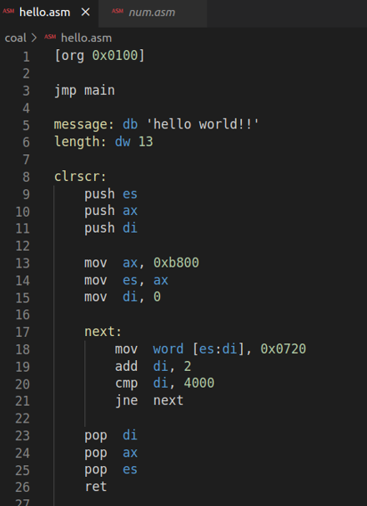

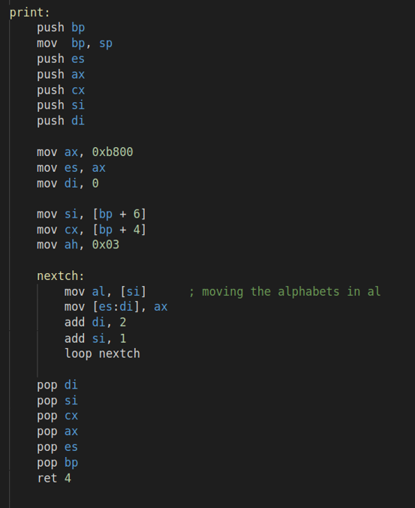

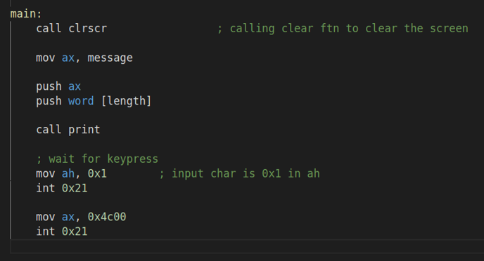

Output:

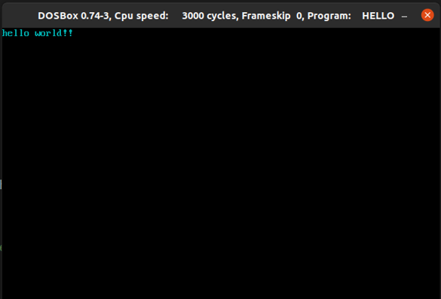

Printing **Numbers** in Assembly:

Code:

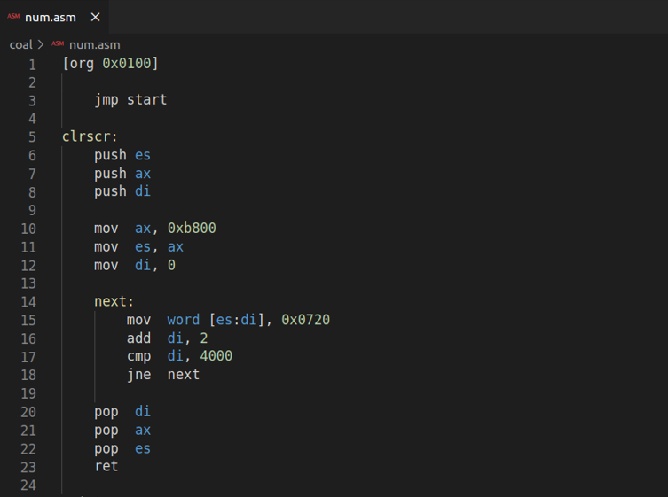

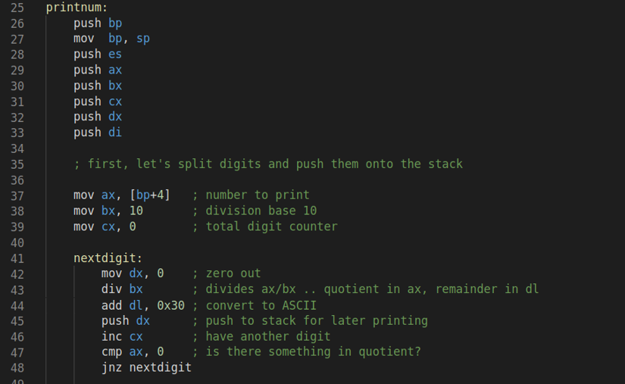

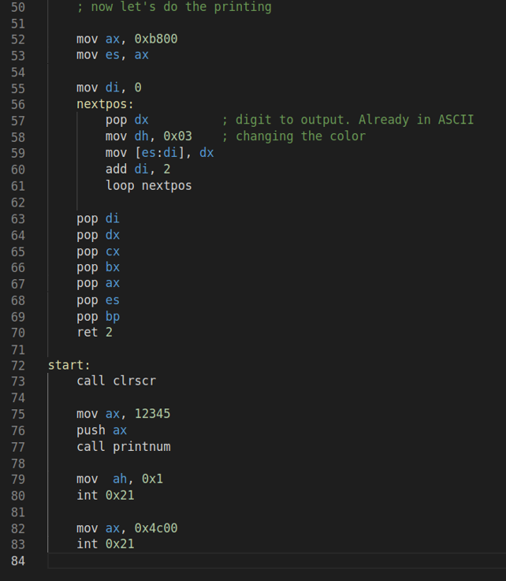

Output:

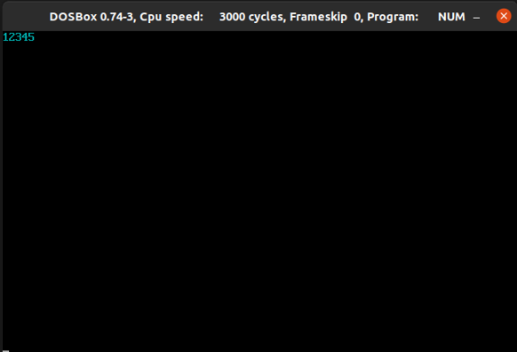

Screen Location Calculation:

As we used a fixed attribute and displayed at a fixed

screen location. We will change that to use any position on the screen and

any attribute. For mapping from the two-dimensional coordinate system of

the screen to the one-dimensional memory, we need to multiply the row

number by 80 since there are 80 columns per row and add the column

number to it and again multiply by two since there are 2 bytes for each

character.

Formula:

**location = (hypos * 80 + epos) * 2**

Code:

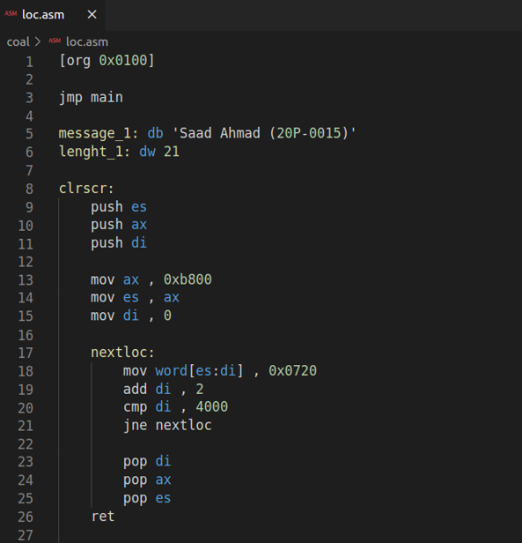

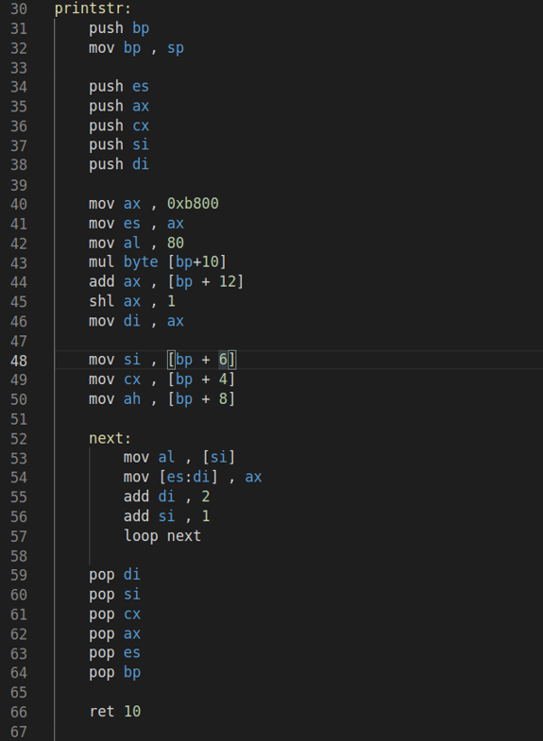

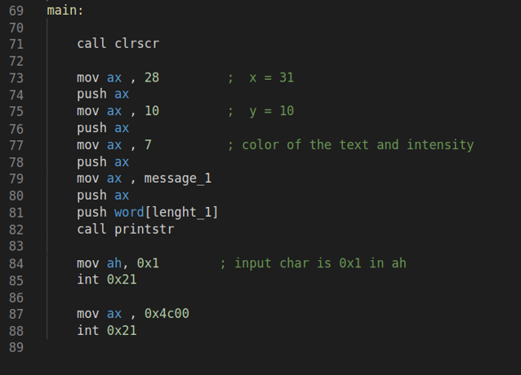

Output:

